Thumbs Up  
Total Knockback GDD

Nick, Angus, William, Ben, Adam, Liam and Matthew

## Change Log:

|  |  |  |
| --- | --- | --- |
| Date | Section | Details |
| 13/09/17 | GDD | Creation of GDD |
| 18/09/17 | Change Log | Changed Format of Change log to be easier to read |
| 18/09/17 | Supplementals | Added UI section to Supplementals |
| 18/09/17 | Supplementals | Cleared up some Wording and number is Character Supplemental |
| 03/10/17 | Supplementals | Added the Level Progression, Updated the Pressure Plate’s |
| 03/10/17 | Game Overview | Added End Goal and reasoning behind |
| 03/10/17 | Core Mechanics | Removed the ‘loot’ from the mechanics |
|  |  |  |
|  |  |  |

## 

## 

## Table of Contents

Change Log: 1

Table of Contents 2

Overview: 4

Elevator Pitch: 4

Classic Hack and Slash with insane, almost ludicrous levels of power play. 4

Game Overview: 4

Setting Overview: 4

Selling Point: 5

Why is it innovative? 5

Hardware 5

Gameplay 6

Core Mechanics: 6

Combat 6

Swarming enemies 6

Loot 6

Other Mechanics 7

Levels/Areas 7

Characters 7

Enemies 7

Mini Boss 8

Boss 8

Special Moves 8

Health 8

Gold Counter 8

Controls: 9

Loops 10

Session Loop: 10

Game Loop: 10

Level Loop: 10

Moment to Moment Loop: 11

Exit Loop: 11

Looks & Feels 12

Mood Board: 12

Art Influences: 13

Audio Influences: 13

Mechanical Influences: 14

Scope & Resources 15

Team Members 15

Scope Overview 15

**Supplementals:** **16**

Characters: 16

Enemies: 17

Levels and Areas: 18

Pressure Plates 18

Reference Games: 19

Barbara-Ian 19

**Ninety-Nine Nights** **20**

Links​ ​to​ ​game: 20

Website: 20

Youtube: 20

How​ ​long​ ​did​ ​you​ ​play​ ​this​ ​game​ ​for,​ ​on​ ​what​ ​platform​ ​and​ ​how​ ​far​ ​did​ ​you​ ​get? 20

What​ ​elements​ ​of​ ​this​ ​game​ ​are​ ​similar​ ​to​ ​your​ ​game​ ​idea​ ​and​ ​how? 21

For​ ​each​ ​of​ ​these​ ​elements,​ ​which​ ​ones​ ​does​ ​this​ ​game​ ​do​ ​well​ ​and​ ​why​ ​? 21

Which​ ​ones​ ​does​ ​it​ ​not​ ​to​ ​well​ ​and​ ​why? 21

What​ ​elements​ ​are​ ​you​ ​interested​ ​in​ ​copying? 21

Provide​ ​details​ ​of​ ​how​ ​you​ ​want​ ​each​ ​element​ ​to​ ​work​ ​in​ ​your​ ​game.​ ​Provide 22

screenshots,​ ​pictures,​ ​photos,​ ​and​ ​sketches​​ to​ ​help​ ​explain. 22

Feedback: 11/9 24

## 

## 

## 

## Overview:

|  |  |
| --- | --- |
| **Genre** | Hack n’ Slash RPG |
| **Platform** | PC |
| **Point of View** | High angle |
| **Theme/Mood** | Medieval Fantasy |
| **Target Audience** | Fans of dungeon RPG games, with high levels of destruction of enemies in games such as Dynasty Warriors |

Total Knockback is a top down hack and slash mixed with RPG elements which generate intense moments with extreme combat and immense communication.

## Elevator Pitch:

## **Classic** Hack and Slash with **insane, almost ludicrous levels of power play.**

## Game Overview:

Total Knockback is a cooperative dungeon crawling game, that involves two people working together as a Sweeper and a Striker. The Sweeper is a large character who can take out hordes of minions with a single swing, the Striker can do a lot of damage to a smaller area and is more suited for taking out big bads.

They must work together to navigate through the levels, find treasure, and try not to die.

The overall goal being to reach the end and kill the ‘Clan leaders’ for each zone (level).

## Setting Overview:

Set in a fantasy medieval world with dungeon crawling knights. They will have to work together to go through areas infested with monsters and dangers to clear it out, including forests and dungeons.

## Selling Point:

A couch Co-op game where you and your friend will have to work together to destroy a horde of enemies, collect treasure, and feel like a destructive powerhouse as you take out 10 minions with a single swing. This game will appeal to people who play games in which their character is a very powerful force in the game, where the little guys are an inconvenience more than a threat because you're just too strong, and you're here for their bosses instead.

## Why is it innovative?

Total Knockback combines the two game types of Hack n’ Slash dungeon crawling, and the being a force to be reckoned with and over the top destruction that comes with games like Dynasty Warriors.

## Hardware

The game will run on the PC. As this game will be top down, with a lot of repeating assets and fixed views, it shouldn't be overly graphically intensive so most computers would be able to run it will little effort.

# 

## 

## 

## Gameplay

## Core Mechanics:

#### Combat

There will be unique combat for each character it will be the main focus of the game

The Sweeper has a wide swing arc of his axe, enabling them to deal with a lot of swarming enemies

The Striker attacks in a straight line with his sword, while he can take out a few minions with this, his strength lies with taking out bigger enemies who need more focused attacks to bring down.

The goal of the game is to give both characters roles in combat that they do well, while still needing the other to make their arsenal complete.

#### Swarming enemies

The smaller minions have next to no health and don't do much damage to the characters, they do however knock the player around a little bit, meaning they aren't much of a threat until there is a lot of them, and you find yourself surrounded

Combat and Swarming Enemies

Dynamics: The players must work together to take out the mass of enemies in the areas, The Sweeper to take out the brunt of the small enemies, and keep the Striker Safe, and the Striker to take out the bigger enemies who need pure damage to bring them down while the Sweeper keeps the smaller enemies at bay.

Aesthetics: This it to help the players feel as though they both have roles to play, and feel useful and as though they need their partner.

## Other Mechanics

#### Levels/Areas

The Levels will be broken up into areas. Theses areas will be broken up into stages and include a few levels, with a larger version of the enemies you face as a mini boss, which will have a visible health bar and be harder to take down as you try to get through.

( Levels/Area Supplementals)

#### Characters

The players will be Broken up into two, The Sweeper to help take down the hordes of enemies, and the Striker, less effective in hordes of enemies, but does more damage than his larger counterpart, enabling them to take down the larger enemies with ease.

(Character Supplement)

#### Enemies

There will be different enemy types throughout the game, some fast, some slow but coming with many many friends, Some that are super super slow but hits very hard

(Enemy Supplement)

#### Mini Boss

Bigger versions of enemies with health bars, more health, and stronger attacks than their smaller counterparts

(Enemy Supplement)

#### Boss

The ‘Big Bad’ of an Area. Needed to be defeated to clear the area.

#### Special Moves

Each character will have a special move which is on a cooldown, the Sweeper will have a spinning attack, enabling them to cleave through hordes of enemies, and the Striker will have a dodge, to help with their mobility and staying out of danger.

#### Health

The characters will have a health bar with [100] and [25] health. The bigger character, that is the Sweeper, is going to have the most health and be able to take more damage than the Striker.

#### Gold Counter

The Score in the game is gold, with each piece collected, the score gets higher.

Pressure Plates

These will allow the players to access different areas and progress through the level.

(Pressure Plate Supplement)

## Controls:

Xbox Controller

|  |  |
| --- | --- |
| Move | Left Stick |
| Look in a Direction | Right Stick |
| Attack | Right Trigger |
| Special | Right Bumper |
| Interact | A |
| Pause | Start |
| Swap Character | Y (must both press within 2 Seconds of eachother) |

## controllerLayout.png

## Loops

### 

#### Session Loop:

Same as game loop but may involve switching which character is being played by which player.

#### Game Loop:

Explore the dungeon levels, kill the mini bosses, find the level with the boss in it, kill boss

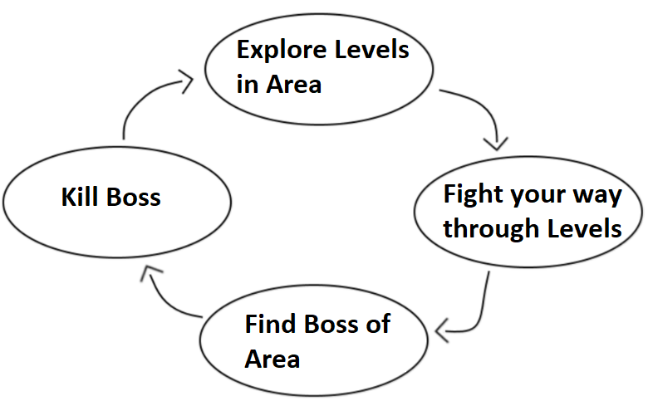

#### Level Loop:

Explore dungeon, kill minions till you find mini bosses, kill Mini boss, find level end

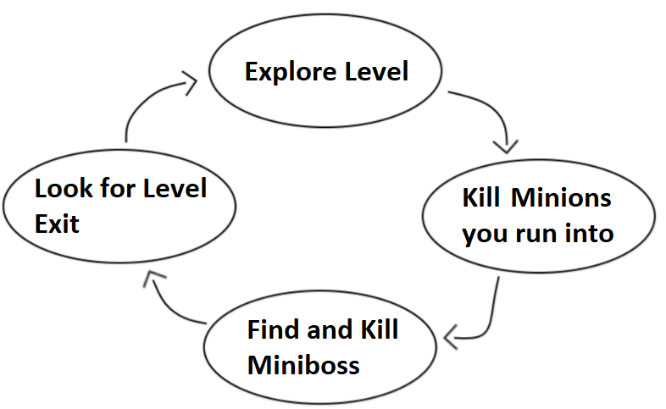

#### Moment to Moment Loop:

Explore the Area, kill Enemies that you come across, Take the dropped treasure

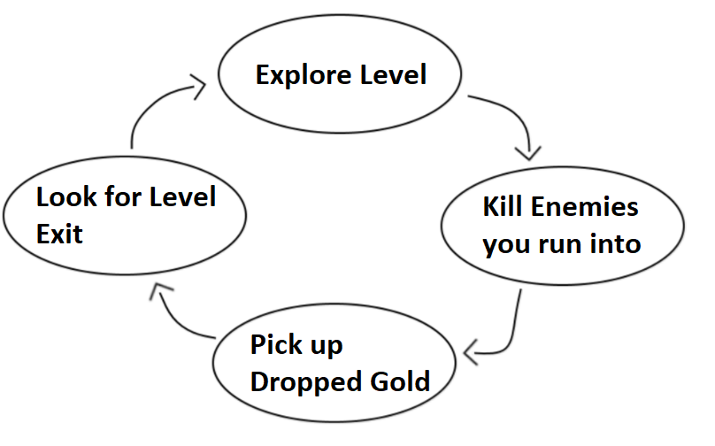

#### Exit Loop:

After a level of the dungeon.

## 

## Looks & Feels

## Mood Board:

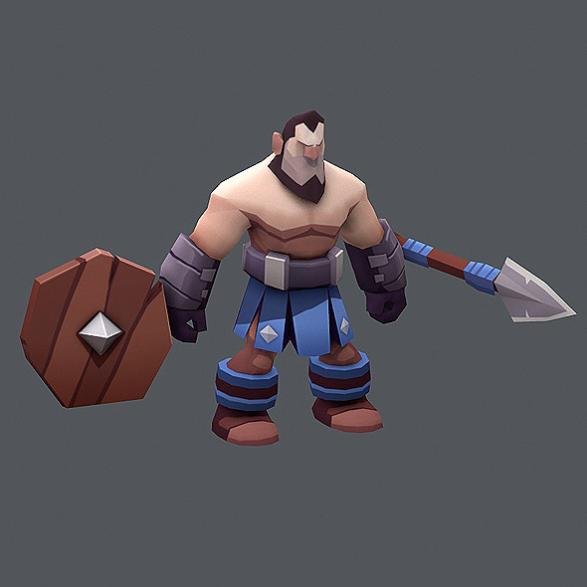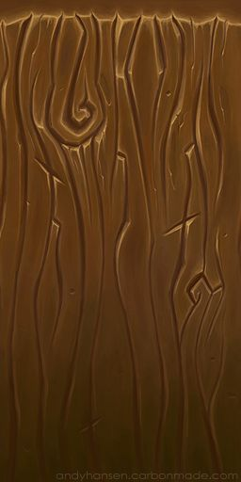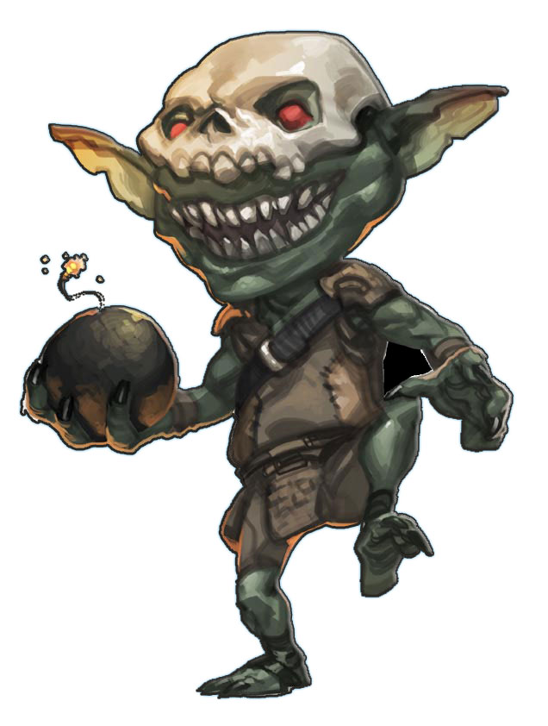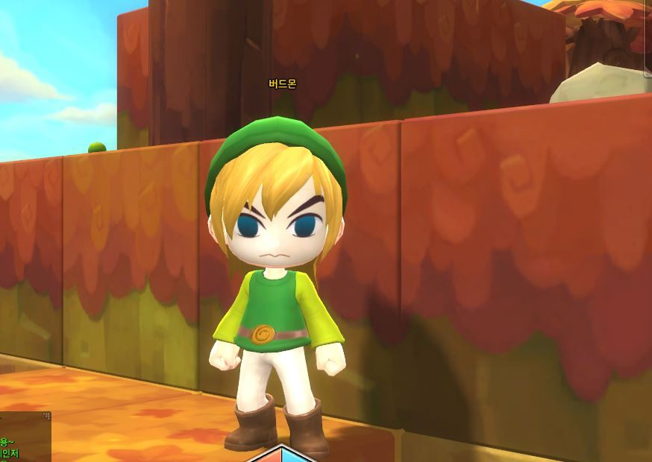

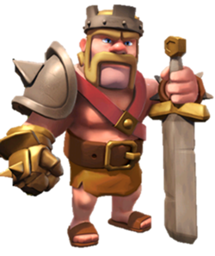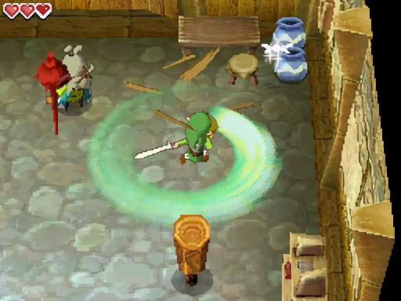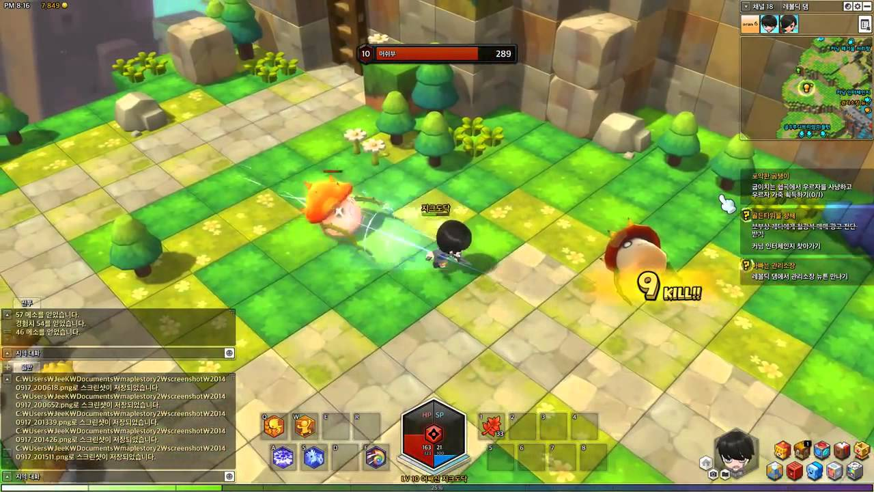

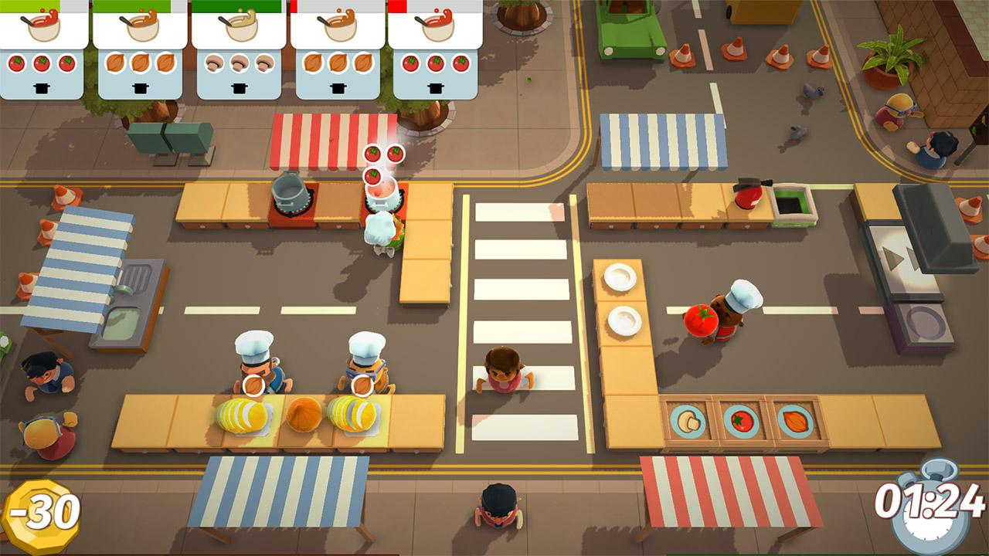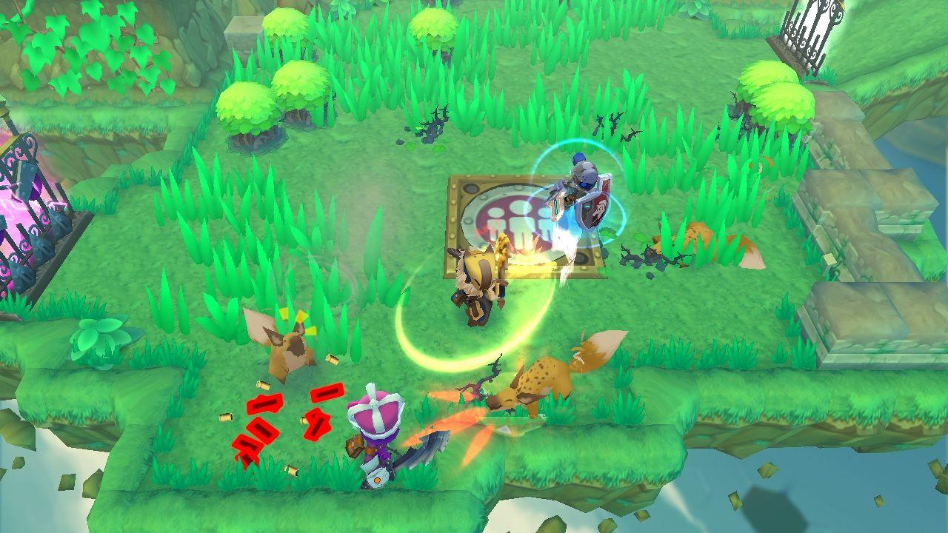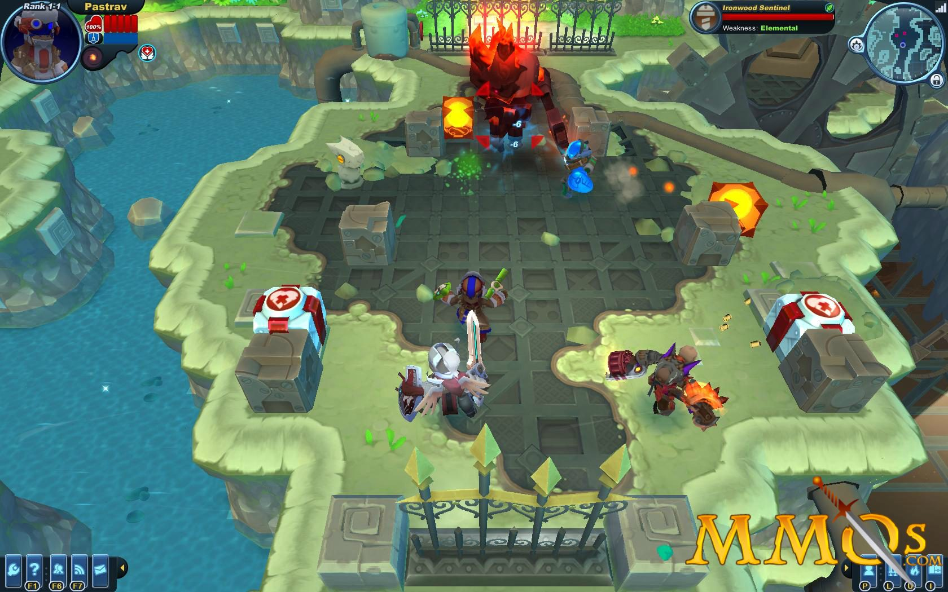



## Art Influences:

## 

**Supercell**

The simple fun, stylized art that keeps it lighthearted. The lowish poly art style keeps the game interesting enough and makes it unquestionable due to its cartoonish nature

## Audio Influences:

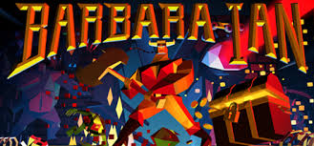

**Barbara - Ian**

The intro for this game is unexpected which makes it truly amazing. Having people just saying the title in tune alongside the thunder and echoing of the singers while they aren’t the most pleasant singers it really shows the games theme. If you leave the intro screen open they keep singing for a few minutes and then the singers break into laughter.

<http://store.steampowered.com/app/380860/Barbaraian/>

## 

## Mechanical Influences:

The Style of combat has the feel of the over the top style influenced by the ‘Dynasty Warriors’ games.

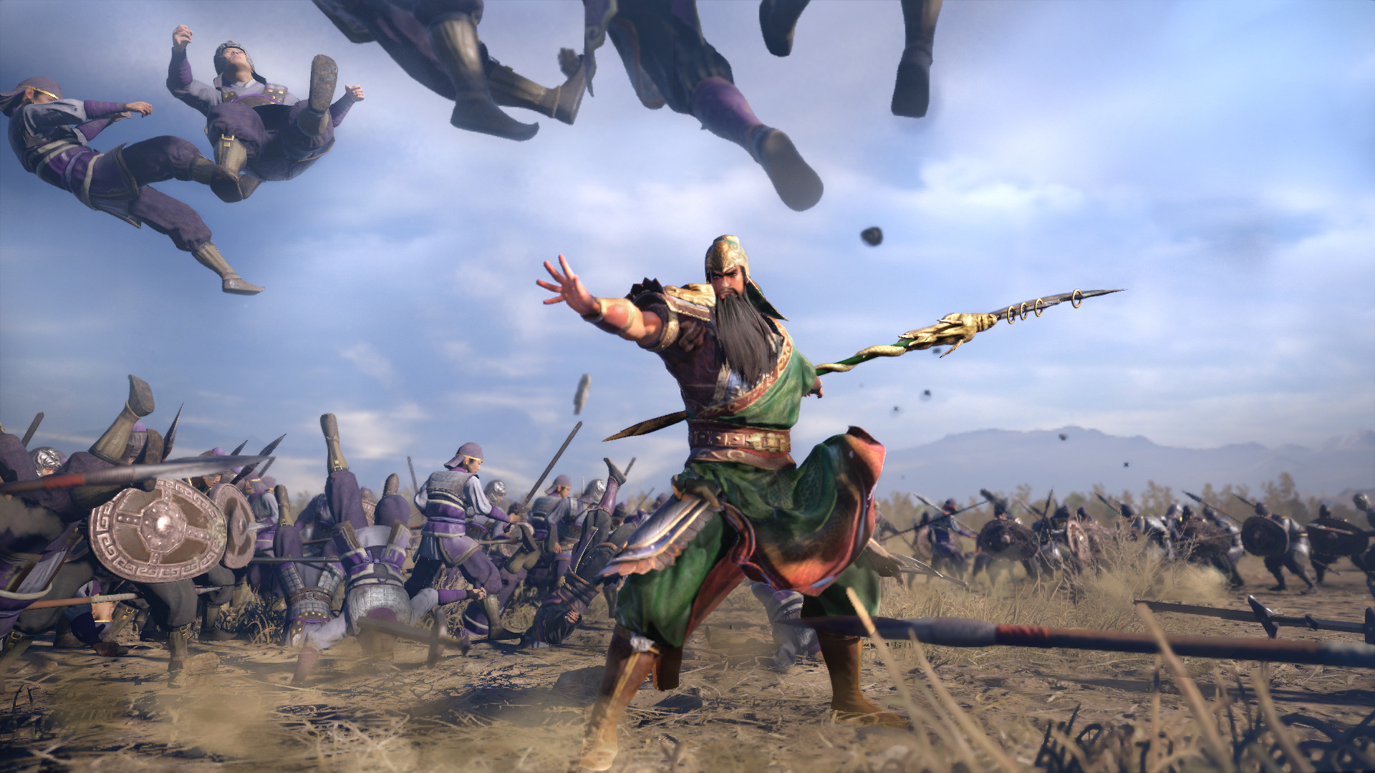

<https://en.wikipedia.org/wiki/Dynasty_Warriors>

With the dungeon crawling combat similar to that of Gauntlet.

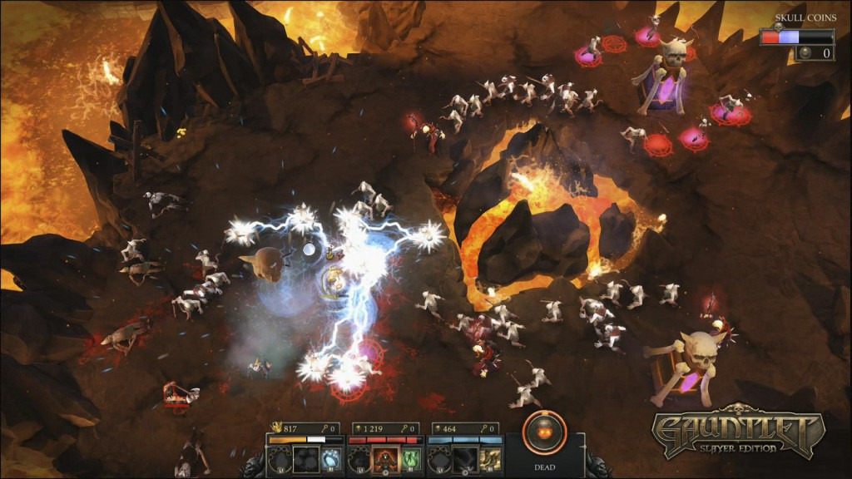

<http://store.steampowered.com/app/258970/Gauntlet_Slayer_Edition/>

## 

## Scope & Resources

#### Team Members

**Producer:**

Nick Barnett

**Designer:**

Angus Phasey

**Artists:**

Will Thong

Ben Bragg

Adam Grincais

**Programmers:**

Liam Knights

Matt Le Nepveu

#### Scope Overview

Pre Production - Documents For setup, Design and Planning Completed - 20th Sep

Alpha - All mechanics in the game - 18th Oct

Beta - Assets in the game, almost completed (without full polish) - 15th Nov

Gold - Finished game, Polished and Handed in - 29th Nov

# Supplementals:

## Characters:

There are two types of controllable characters the **Sweeper** and the **Striker**.

**Sweeper:** Is a large ‘tank’ character which has a large health pool with little damage, slow movements but can destroy low health targets in one attack. They are the only Ones who are heavy enough to stand on buttons to activate them. Their attacks are a sweep in front of them, ideal for taking out smaller enemies in massive droves. The overall damage they do however is low, when up against a boss with lots of health, they aren't quite as useful as the Striker.

**Stats**

* The Sweeper uses a large **axe** to strike down their foes which does **[5]** damage per swing
* Health pool **[100]**
* Sweeper will receive **[1]** health back as they kill a pusher and **[2]** health for when they kill a Shover
* Can **Spin** attack by holding **[RB]** which does **[5]** damage and pushes all enemies back, but it takes **[10]** seconds to recharge. This moves Spins them twice, attacking all enemies around adding **[.5]** distance to their swing. They have reduced movement While spinning.

**Striker:** Is a small damage dealing character which is meant for focusing bosses and high health enemies all while darting around the level with high movement. They can fit through smaller areas that the Sweeper can not. Their attacks happen in a straight line in front of them. They can not take out as many smaller enemies as the sweeper as quickly, but when against stronger enemies with more health, they excel.

The Striker also has the ability to drag **[boxes]**. This allows him to activate the pressure plates. This will decrease movement speed and he will be unable to attack until he lets go of the **[box]**

**Stats**

* The Striker uses his **sword** to pierce the enemies dealing **[20]** damage
* Health pool **[25]**
* The Striker will receive **[2]** health after killing a Shover, and regains all health when they kill a mini boss
* Can **charge** attack by holding **[RB]** which does **[50]** damage but it takes **[3]** seconds to charge. This moves them in a line in the direction they are facing

When a player dies the living player gains traits of the character they aren’t playing. Their **souls** combine.

**Sweeper Alive - Striker Dead**

* Sweeper will gain **[10]** extra damage on top of the original **[5]**

**Striker Alive - Sweeper Dead**

* Striker receives an extra **[15]** to create a total pool of **[40]** health.

A player can be **revived** if the player places the player's soul back into their character.

* The player that has been killed will have to wait **[15]** seconds before the living player can revived them.
* The living player must stand over the killed player’s body for **[3-5]** seconds before they are revived

If both players die the game ends and their score is displayed.

## Enemies:

There are **three** variants of enemies. **Grunts**, **Mini Bosses** and **Boss**.

**Grunts & Mini Bosses**

* **Pusher** (Grunt), is a small enemy that does **[little or no]** damage and is basically just an annoyance to the players. Pushers will swarm the players and push them out of the way, this will only affect the Striker as he will be the same size as them. Health pool of **[5]**
* **[Shover]** (Grunt) is a small enemy with a weapon that deals **[5]** damage to the player. They will be found within groups of Pushers to add the threat level to as group of non damage dealing enemies. Health pool of **[10]**
* **[Throwers]** (Grunt), small enemy that throws a projectile that deals **[10]**. Health pool of **[5].**
* **[Spirit]** (Mini Boss) is a ranged enemy that shoots a projectile that deals **[20]** damage on hit of a target **[Long]** range with slow movement speed. Health pool of **[80]**
* **[Mad Man]** (Mini Boss) a large enemy who has a **[Fast]** move speed and **[slow]** attacks dealing **[15]** damage per swing. Health pool of **[100]**

The Mini Bosses will be in every few groups found throughout a level.

* **[Boss]** Large enemy that waits in The final area for the Players to show up. They will have **[200]** hp and deal **[25]** Damage per Attack. It will move slower and rely on the smaller enemies to slow down the players to catch up and deal a devastating blow

## Levels and Areas:

A single level will be broken into 4 areas.

**Three Areas -** will be a large landscape area that has multiple rooms branching out allowing the player to explore.

**Level Progression:** The levels are broken into three areas and the players must travel and eliminate all enemies in an area or unlock the gate, to proceed to the next area. Once the player has killed all enemies in the final area the complete the level.

## Pressure Plates

There will be pressure plates around the area that will open doors progressing the players through the level.

The Plate is on the ground and there are two ways it can be activated:

1. The Sweeper must stand on a Plate - this will only open the gate halfway.

2. Both the Sweeper and a Crate must be on a plate each to open the gate fully.

## UI

Both characters will have a Health bar and a Cooldown Icon for their special Attacks, and a Joint Gold counter.

When a boss shows up his health will also be displayed on the screen.

**The main menu -** The main menu will consist of a start game, quit game, and options menu, which will have sound controls.

# Reference Games:

## Barbara-Ian

<http://store.steampowered.com/app/380860/Barbaraian/>

I have played this for 50 minutes on PC (steam)

The things that I feel would work for my groups game is:

* Camera
* Combat

**Combat**

* Now the combat isn’t amazing but what it does well is, making the player feel powerful. A single swing of her sword and you can kill a whole group of enemies. The **feedback** is what makes this so great because once an enemy is hit, no matter their size they will go flying and spurt blood all over the place.
* This is what i would like to copy. The crazy feeling of power.

**Camera**

* This is just the general angle we are going for and it smoothly follows the player.

I feel as though the game itself is an **unfinished** and there's a lot of things that need to be fixed and just general touch ups and bug testing.

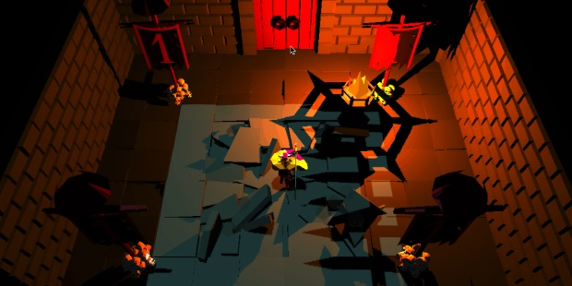

<https://www.rockpapershotgun.com/images/15/feb/barbaraian-01.jpg>

## Ninety-Nine Nights

#### Links​ ​to​ ​game:

<https://en.wikipedia.org/wiki/Ninety-Nine_Nights>

#### Website:

<http://ninetyninenights.wikia.com/wiki/Ninety-Nine_Nights>

#### Youtube:

<https://www.youtube.com/watch?v=E5xxyep-IzE>

#### How​ ​long​ ​did​ ​you​ ​play​ ​this​ ​game​ ​for,​ ​on​ ​what​ ​platform​ ​and​ ​how​ ​far​ ​did​ ​you​ ​get?

A little over 1 hour played, got up to the 5th Level (Fort Wyandeek)

### 

#### What​ ​elements​ ​of​ ​this​ ​game​ ​are​ ​similar​ ​to​ ​your​ ​game​ ​idea​ ​and​ ​how?

* Combat - The combat has the over the top, lots of enemies that are just fodder to your character, you just cut through them like they are nothing on the battlefield as you search out the harder targets.
* Power Bar - As you kill enemies you power up the “Super” bar, when it's maxed out you go into a super mode and can move fast, swing far, and destroy the battlefield
* The dash is very similar to what we were talking about for the striker, it enables dodging and maneuverability

#### For​ ​each​ ​of​ ​these​ ​elements,​ ​which​ ​ones​ ​does​ ​this​ ​game​ ​do​ ​well​ ​and​ ​why​ ​?

This game employs a combo system, keeping track of how many enemies you hit in succession to add to the feeling of destroying your opponents. This coupled with the over the top combat and an ever growing kill counter gives the player the feeling we are hoping to achieve.

#### Which​ ​ones​ ​does​ ​it​ ​not​ ​to​ ​well​ ​and​ ​why?

This isn't necessarily not done well, but more gone in a different direction to how we were looking, but the combos in this game are very arial, it involves a lot of hitting the enemies around then destroying them in the air or on the way down. It has a very JRPG feel of massive swinging combos and fancy animations to glide through the battlefield. While a fun direction to go for that style of game, it's a little too different to what we are looking at.

#### What​ ​elements​ ​are​ ​you​ ​interested​ ​in​ ​copying?

The over the top swings and enemies going flying is done well in this game, and the combo counter and power bar are balanced and give the player the feeling of destruction. The Goblin enemies are simple and would be good to look at for reference, not necessarily in art style but in how they made them simple.

The dodging mechanic of the female lead character is not to over the top but still useful.

#### Provide​ ​details​ ​of​ ​how​ ​you​ ​want​ ​each​ ​element​ ​to​ ​work​ ​in​ ​your​ ​game.​ ​Provide screenshots,​ ​pictures,​ ​photos,​ ​and​ ​sketches​​ to​ ​help​ ​explain.

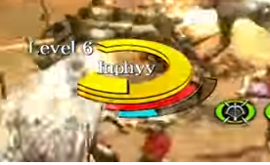 Red bar - Power bar that charges as you kill enemies, unleashing new power or mode when full

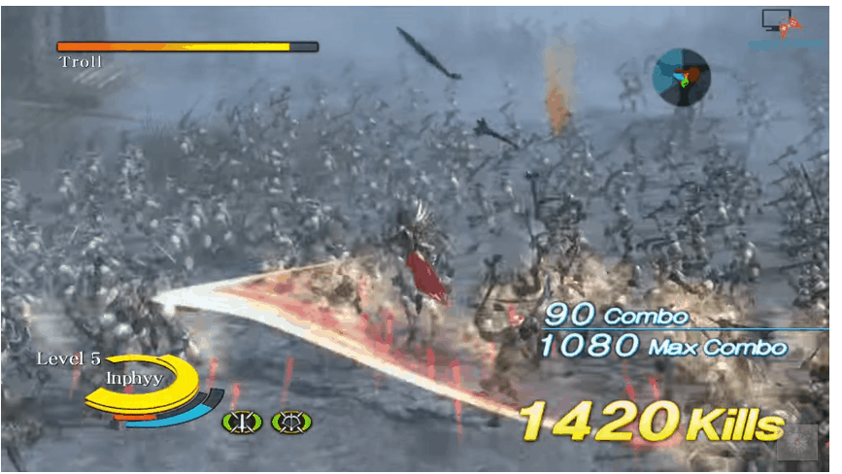

Lots of enemies, and weapon just cleaves through them all. High levels of power play in the combat to make the player feel incredibly powerful.

Also the combo bar and the kill count.

## Feedback: 11/9

**Zane Talbot**

* Having Dynasty Warriors in the sales pitch may alienate people who haven't played it, you could possibly just (in a word or two) explain what about Dynasty Warriors you're taking for your game ie. **Classic RPG with insane, almost ludicrous levels of power play.**
* Gotta be a tad careful with combat, if you say the sweeper 'has an arc' then you need to outline specifically how wide the arc is/what the reach is etc - which you can tackle in supplemental.
* An accompanying image of the controller would help get the controls across faster/easier.
* This isn't real feedback but I love that you used a company's art style and referenced a few games under one sub-heading. Simple and effective!
* I'm sure this is in the pipeline when your artist gives you concept art, but more images in the mechanics phase and under supplemental for the characters and enemies etc.
* Nitpicking: Under level and areas in supplemental you've outlined [three] areas, and then the next line you've said it breaks up into [4] levels - just for consistency you may want to pick either numbers [4] or letters [four] and stick with one the entire doc.

**Charlie Bennett**

The characters and enemies each have their attackable area described roughly but not aren't completely defined. From what I've read the sweeper has an arc, the striker has a needle like attack area.

If the Striker is more maneuverable what is the movement speed of the characters is it different or just the dash gives it superior maneuverability?

For the striker entering otherwise excluded areas how does this work? Is it like special treasure rooms full of grunts that only the striker can enter?

Does the camera scale in and out incase players separate, whether due to the strikers movement being faster?

Are the characters placed within the level or randomly spawning from spawners?

When a character dies can they return or be revived or does the other player have to continue on?